Reviewer #1 (Rationale for Significance Rating for Authors):
The data set and design of the study are interesting, and the manuscript is overall well written. The main claim is that the neural representations elicited by visual stimuli have a degree of "cue-invariance" quantified by a "cue-transfer decoding" method, but unfortunately it is not clear what this tells us about the structure of the neural representations.
Reviewer #1 :
This manuscript studies the structure of stimulus-evoked neural activity patterns in V1 and V2 of macaques. The data set and design of the study are interesting, and the manuscript is overall well written. The main claim is that the neural representations elicited by visual stimuli have a degree of "cue-invariance". The central analysis to support this is termed "cue-transfer decoding", which involves fitting a Procrustes transformation (or perhaps just a rotation according to the methods) between the neural activity patterns from different visual stimulus sets.

Reviewer's point 1 – terminology cue-invariant or cue-equivariant
Let's start with a note on terminology: "cue-invariant neural representations" doesn't quite sound right in two ways. First, even if there was an invariance of the neural representations, it would be with respect to the rendering/appearance, not with respect to other features of the visual cue. Second, the neural representations aren't actually invariant if they need to be mapped by a Procrustes transformation to generalize from one rendering style to another. I believe the correct mathematical term for such a situation would be "equivariant", so a term like "rendering-equivariant neural representations" would be more accurate. (As an aside, I would argue that we already knew that at least in the human visual system, the neural representation in the early visual system cannot be truly invariant to rendering style, otherwise we couldn't distinguish different renderings of the same contour - this point should probably be mentioned when motivating the study).
Reply to point 1
[Not addressed] [framing/wording change]

Reviewer's point 2 – simple geometric measures like angles and distances
The properties that are actually invariant under a Procrustes transformation are relative distances between pairs of points (neural representations) and angles between them (i.e., the "shape" of the neural geometry, but not its overall scale). It seems puzzling that the authors don't test their main hypothesis directly in terms of these geometric quantities. Relative distances and angles of the neural geometry are easy to compute and compare across different renderings, without training any decoders. The RSA analysis of Fig. 3 makes a start in this direction, but of course one cannot say much from these dimensionally reduced plots. What would be needed to argue that there is a geometric structure in the neural representations that is approximately preserved between rendering styles is a systematic quantification of these properties (angles and relative distances), with a careful statistical comparison to a control model to investigate the degree to which they are preserved.
Reply to point 2
I. The direct reply: simple geometries show equivariance/invariance but modest - response mean geometry: pairwise distances and centroid-anchored angels
Related scripts: geometric_metrics_basic.m
Method: It builds two geometry matrices from the 50 stimulus-mean vectors in each rendering: pairwise Euclidean distances, and centroid-anchored cosine similarity (cosine between each mean and the others after subtracting the grand centroid of all 50 means). Cue-invariance is then the cross-rendering Pearson correlation of these matrices — over the 1225 unique off-diagonal pairs (triu(...,1), diagonal excluded so self-distance-0/self-cosine-1 don't inflate anything). For each rendering pair it draws three bootstrap distributions — Observed (per-trial-resample cross-rendering r), Null (stimulus-label shuffle nested inside the bootstrap so noise structure matches), Ceiling (two independent within-condition resamples per AC/EC/EX) — plus a trial-averaged point estimate (black triangle). Runs under two normalize_modes: raw, or zscore (per-neuron on the 500×N matrix, matching the decoder).
Result: while the general pattern holds across monkeys and visual areas, only KO V1 results (the best one) are shown here. Other figures can be found at ..\decoding-analysis\neuronal_decoding\results\figures\simple_geometrics\mean_of_trials
Two groups of figures computed using raw or per-neuron zscored spike counts. They are similar in general patterns, with z-scoring having higher values.
Start with the z-scored results.
i. heatmaps for stimulus-pairwise distance/cosine
The trial-averaged heatmaps (named “heatmap_avg”) show the geometry itself — three panels, one per rendering, each a picture of the fifty-by-fifty distance or angle matrix. The metrics are computed with trial-averaged means. The three panels resembling one another is the invariance, made visible directly. The trial-resampled heatmaps (named “heatmap_rs”) show the same thing built from the bootstrap-smoothed geometry instead, i.e, resample trials with replacement to compute the stimulus mean and then compute the metric; they look almost identical to the averaged ones.
“dist_” pairwise stimulus distance
“cos_” grand centroid anchored, pairwise stimulus angle cosine value
“dist_heatmap_avg_zscore.png”
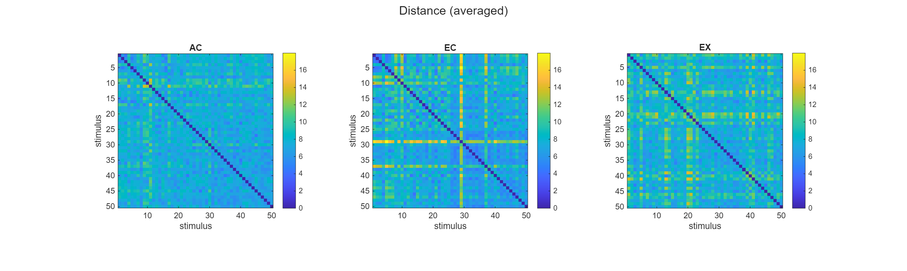
“dist_heatmap_rs_zscore.png”
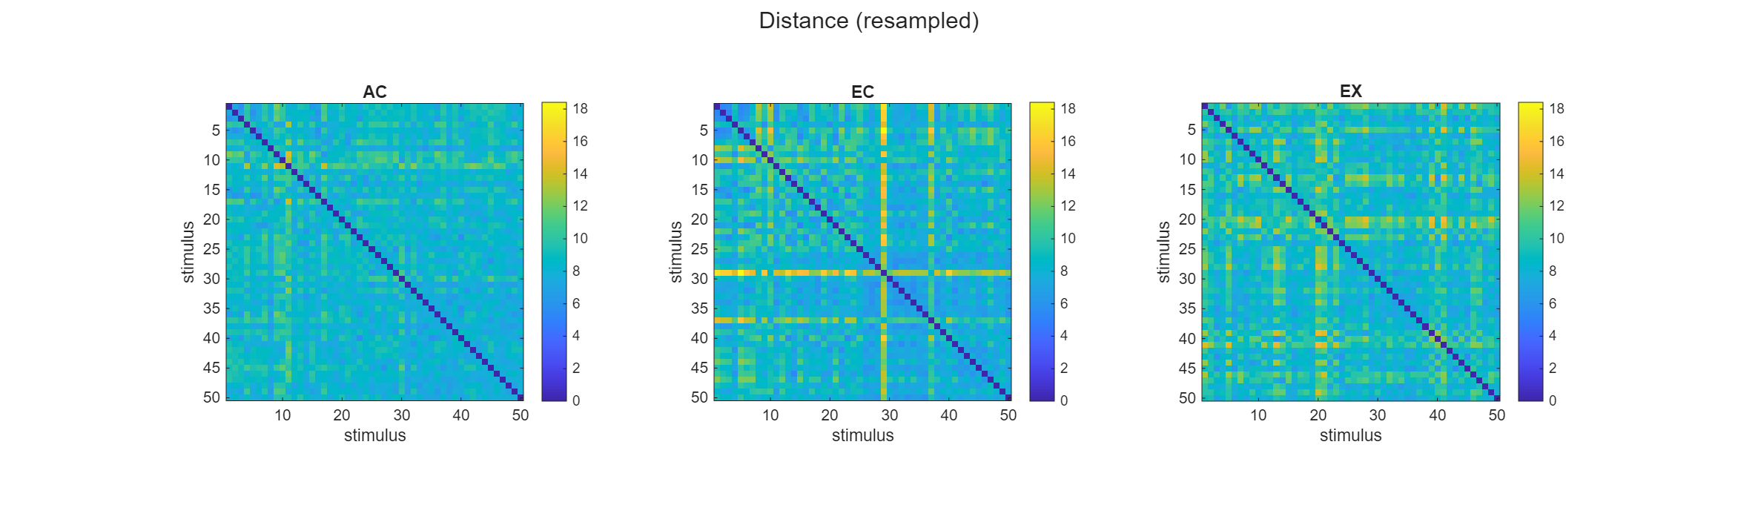
“cos_heatmap_avg_zscore.png”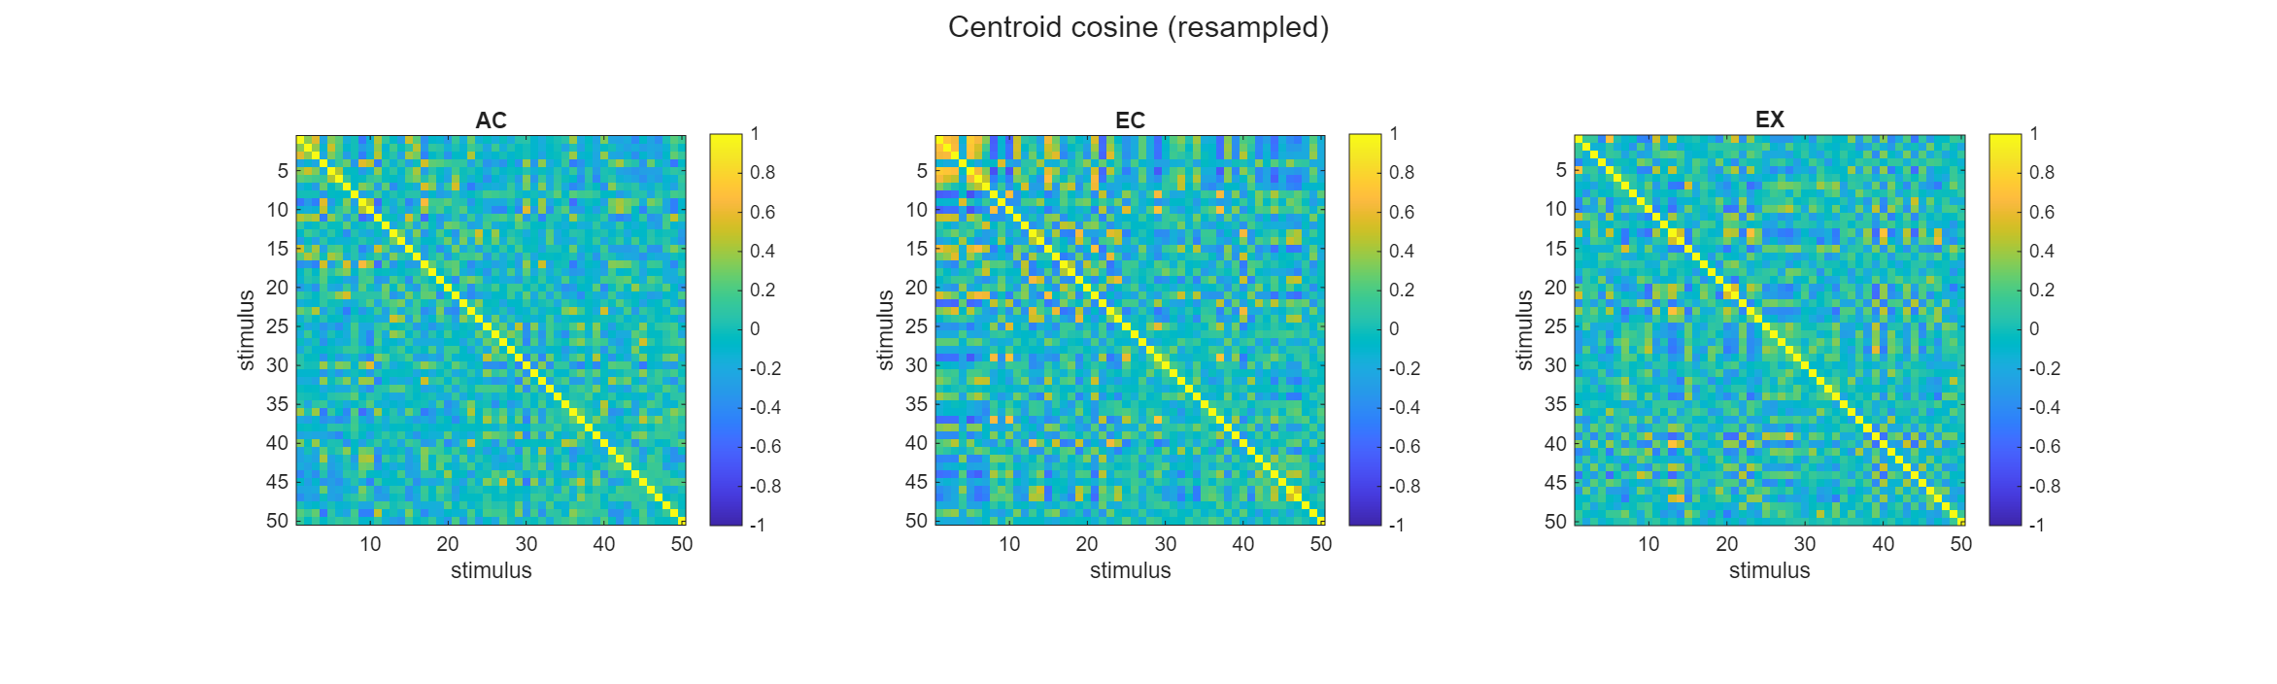
“cos_heatmap_rs_zscore.png”
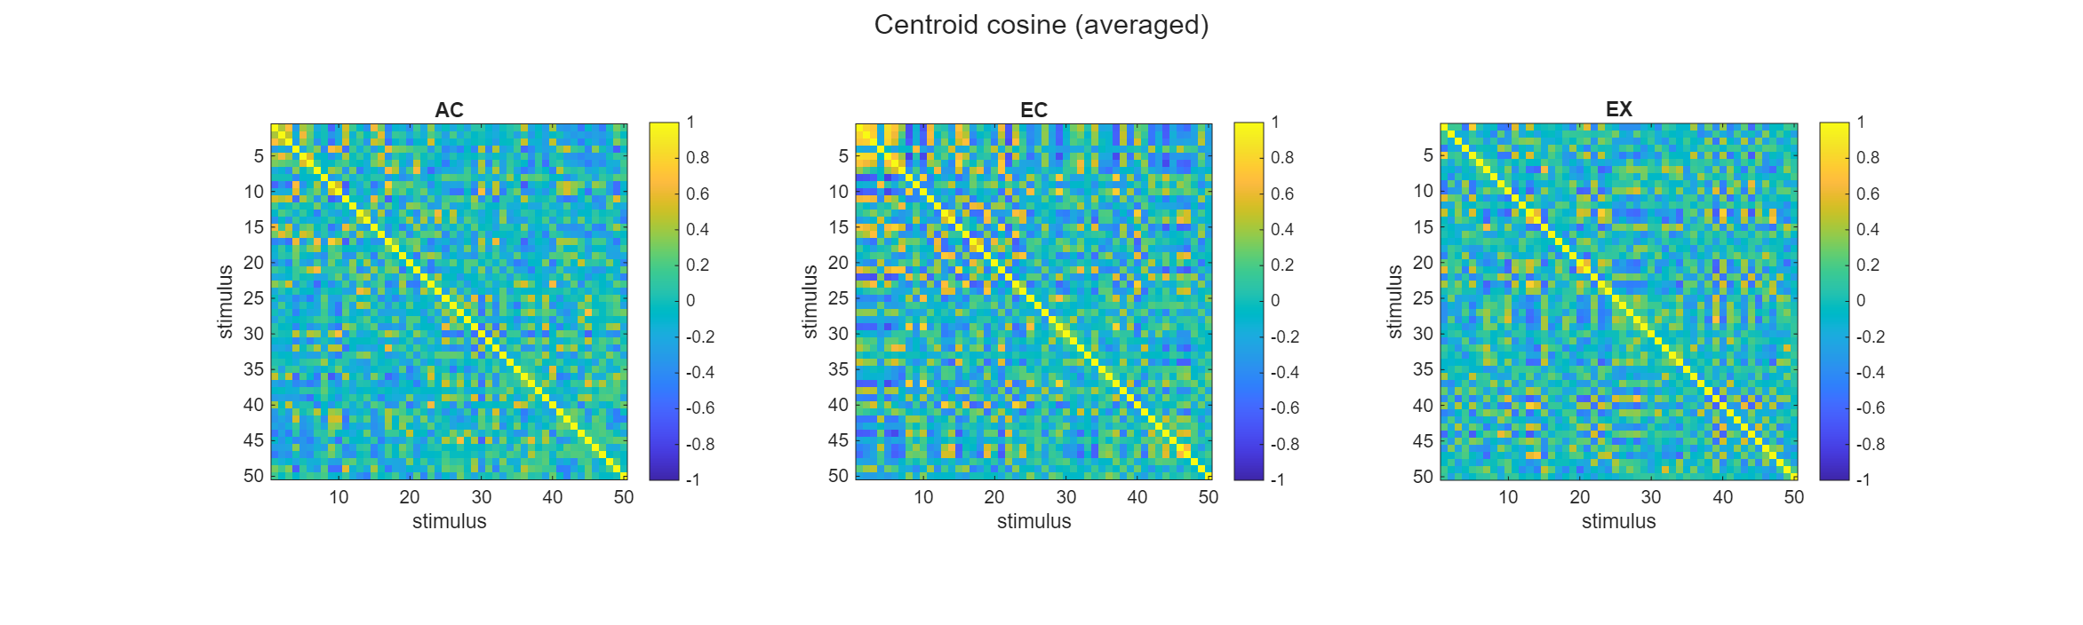
Interpretation: there are corresponding cross-like patterns across renderings. We need to quantify the invariance between cues, by computing the correlation.

ii. scatter plots of geometry metrics across renderings
The averaged scatter plots (named “scatter_avg”) take those same two geometries and plot one condition against the other, one dot per stimulus pair, so a tight diagonal cloud means the two conditions rank their stimulus pairs the same way. The resampled scatter (named “rs_avg”) does this on the smoothed version. It is built from the average of all 100 resamples. These are the visual form of the correlation number.
“dist_” pairwise stimulus distance
“cos_” grand centroid anchored, pairwise stimulus angle cosine value

dist_scatter_avg_zscore
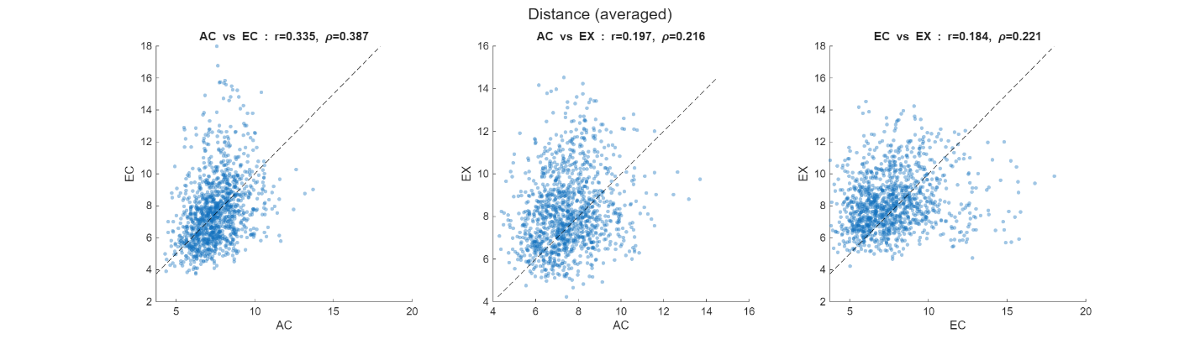

dist_scatter_rs_zscore
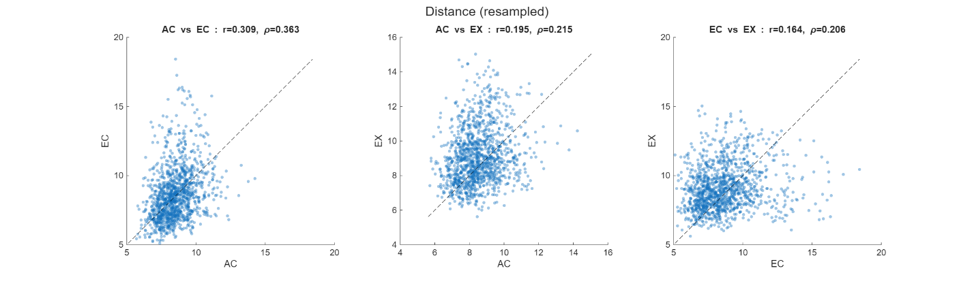

cos_scatter_avg_zscore
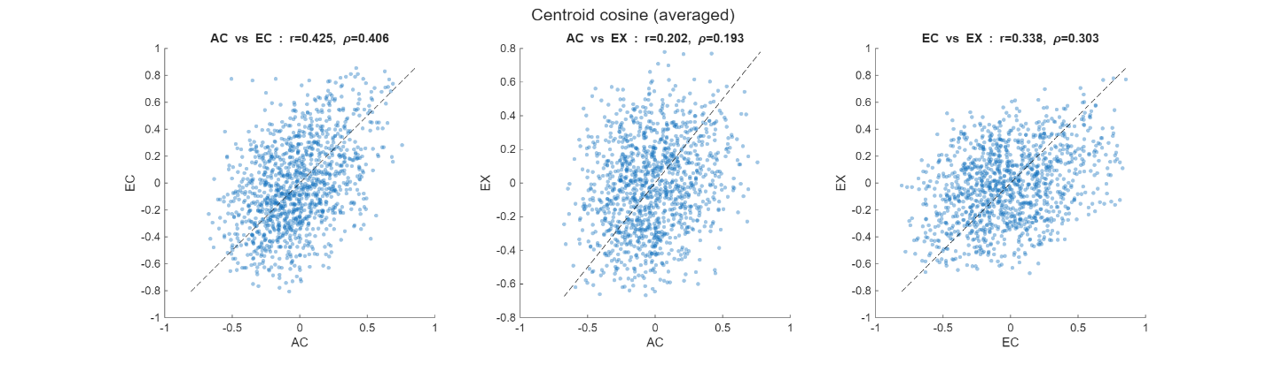

cos_scatter_rs_zscore
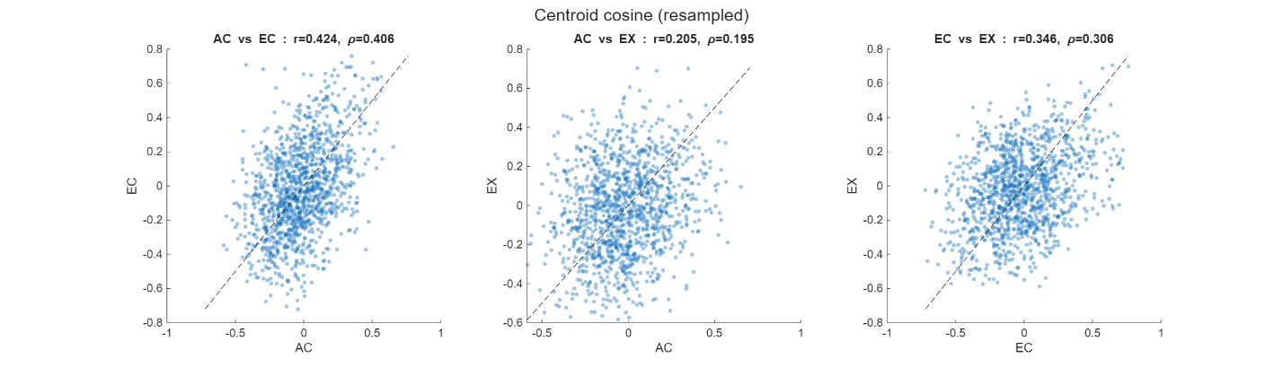

Interpretation: The scatter plots showed some modest correlation. We further quantify it by plotting the resampled and averaged correlation values against the self-ceiling and nulls.

iii. Distribution of correlation values
First, some explanations:
Trial-averaged Pass (deterministic). just averages all ten repeats of each stimulus, builds the geometry once, and correlates the two conditions once. This is the honest point estimate: the black triangles in the distribution plots.
Bootstrapped Pass (100 iterations). Repeat the above process a hundred times, each time drawing ten repeats with replacement before averaging, so the stimulus points wobble a little from draw to draw. Two useful things fall out of this. Averaging the hundred wobbled geometries together gives a smoothed version of the geometry, and recording the cross-condition correlation on each individual draw gives a whole spread of correlations rather than a single number — that spread is the so called "obs" distribution.
Ceiling pass — 100 iterations. sks how faithfully a single rendering even reproduces its own geometry. Within one condition it draws the trials twice, independently, builds two geometries, and correlates them. Because these are the same stimuli under the same condition, this is the most agreement you could ever hope to see across conditions; the true cross-condition correlation is bounded by it. It is called “AC/EC/EX self”
Null pass (1000 iterations). It is the opposite reference. It resamples exactly as before but scrambles which stimulus is which in one condition before correlating, so any real correspondence between the two geometries is deliberately destroyed. Whatever correlation survives that scrambling is what you'd get by chance.
dist_distributions_zscore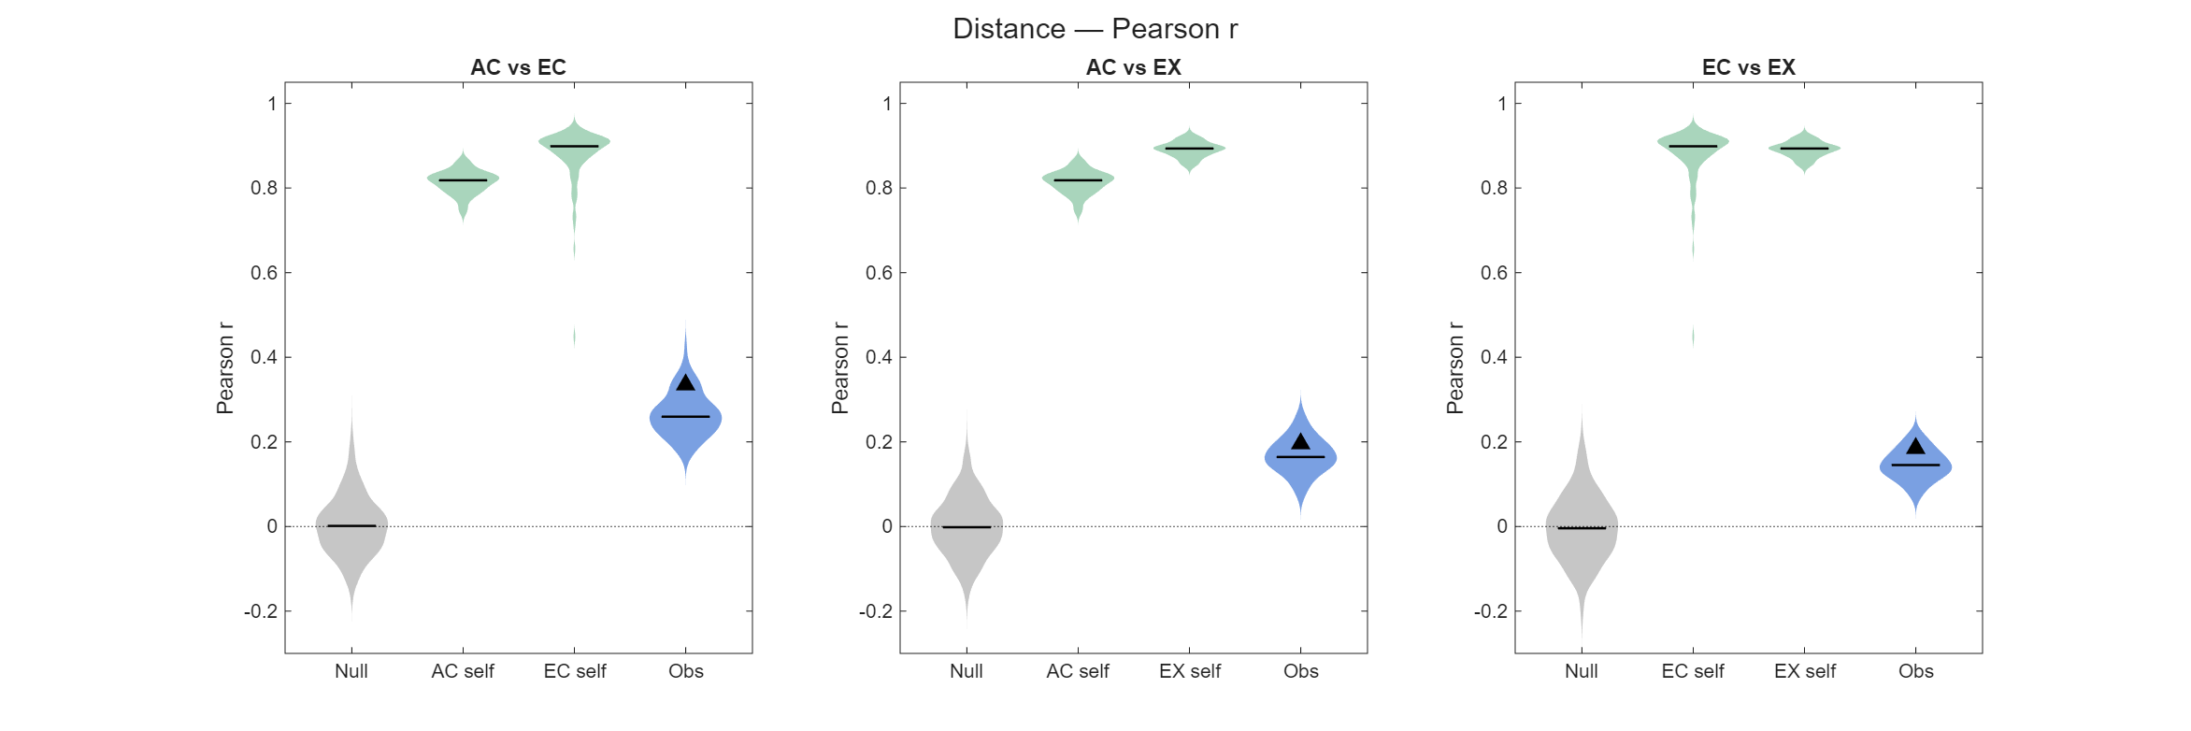
cos_distributions_zscore
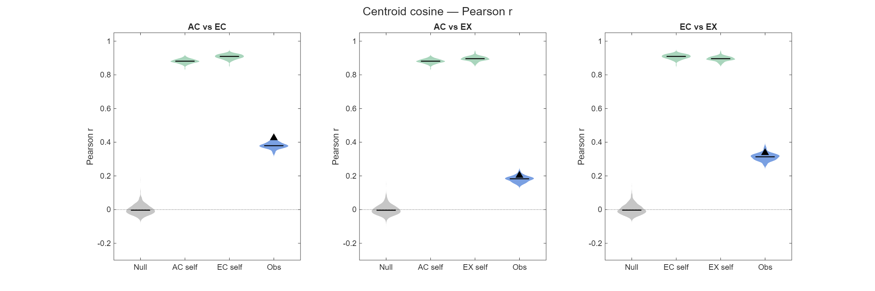
I only attached the summarized distribution for raw spike count here; other lower-level computation figures can be found in Git Repo: decoding-analysis\neuronal_decoding\results\figures\simple_geometrics\mean_of_trials
dist_distributions_raw
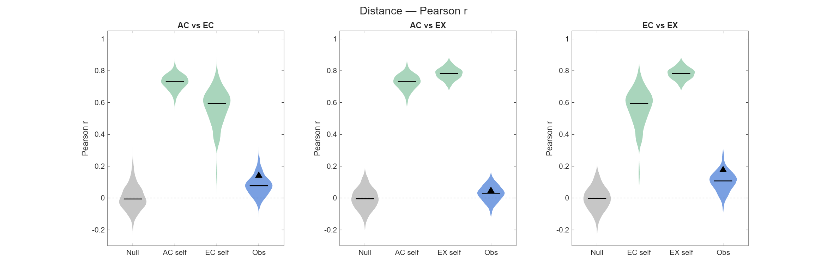
cos_distributions_raw
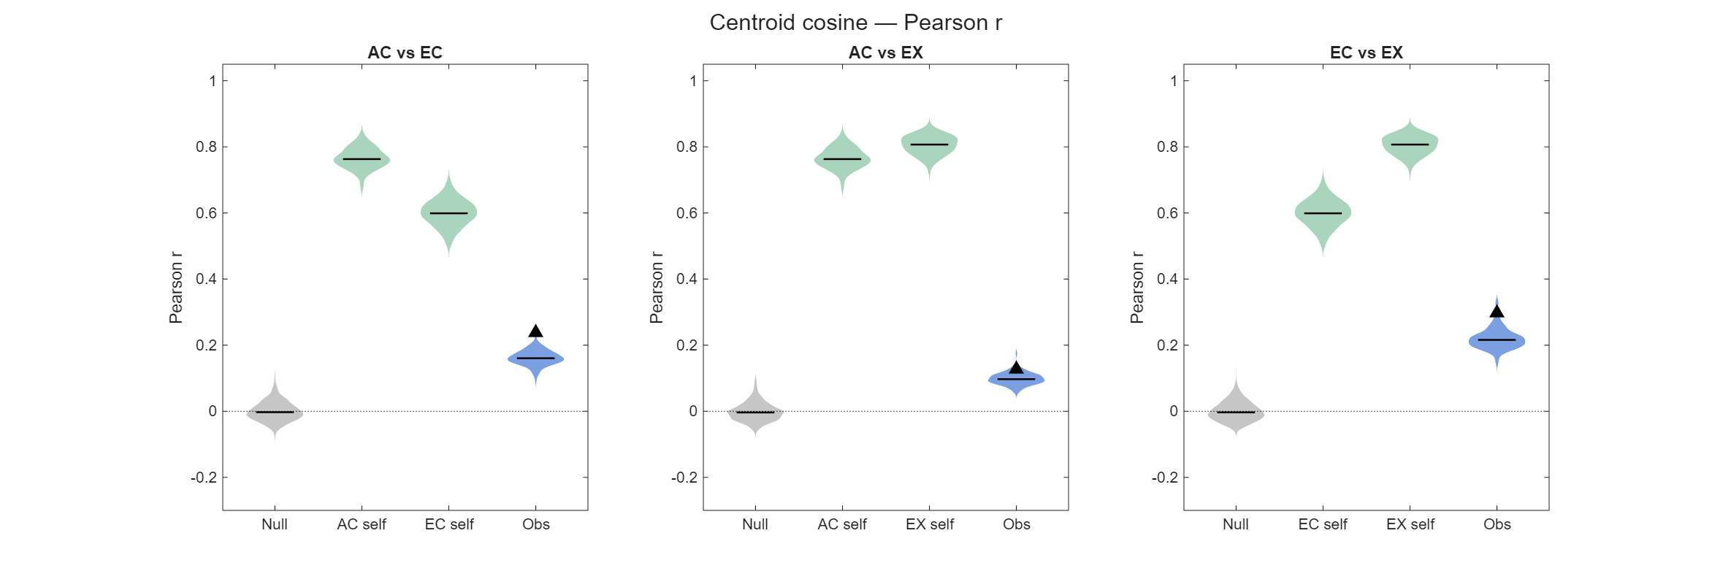

Overall conclusion: cross-rendering geometry correlation is clearly above null but well below ceiling — e.g. KO V1 z-scored: AC-EC ≈ 0.38, EC-EX ≈ 0.32, AC-EX ≈ 0.19, against ceilings 0.88–0.91 and null ≈ 0. Partial, not perfect, preservation of the shape — which is the honest decoder-free version of the claim. Note raw distance is nearly flat (0.06–0.11) and z-scoring is what reveals the structure; the paper's decoding pipeline z-scores too, so this is consistent.

II. Supporting / documented negatives (use to show the search was thorough)
i. negative: which trials carry the geometry; do the trials away from the per-stimulus mean preserves (outliers) the geometric structures better? The answer is no.
Related scripts: geometric_metrics_characteristic_trials.m
Method: pre-empts the alternative explanation that single-trial decoding rides on a few high-magnitude/outlier trials.
Each stimulus mean is recomputed from k selected trials, sweeping k = 1:10, under three selection rules — far / near / random (distance from each stimulus’ population response center) — with the full k=10 mean as reference and a shuffled-random-k null. center_mode is global (grand mean, primary) or own (per-stimulus mean, negative control). It then runs the same cross-rendering correlation as the basic script on these truncated means, boot_repeat = 500.

Reviewer's point 3 – two classifiable multiclass manifolds must be relatable by a rotation (?)
This leads us to the main point of this review: the crucial component that is unfortunately missing in this manuscript is evidence that successful transfer decoding actually implies a special geometric structure ("invariance") of the neural representations, as the authors claim. This is not obvious, because the rotation that is fit to transform the neural representation has a lot of parameters (of order N^2 for N neurons). For a linear SVM (which is how the authors describe their decoder in the main text) it is easy to see that the cue-transfer decoding procedure does not imply any special geometric structure of the neural representations. This is because the predictions of a linear SVM depend solely on a decision boundary described by a hyperplane in the neural activity space, and a rotation of the activity patterns is equivalent to a rotation of this hyperplane. This means that as long as one decoder can correctly classify the stimuli for one rendering, and another decoder can correctly classify them for another rendering, cue-transfer decoding will work, because the Procrustes transformation of the representations can effectively turn the decision boundary of one decoder in that of the other one. (This is related to the fact that the decision boundary is specified by only N parameters - much fewer than those involved in fitting the rotation).
Reply to point 3

Reviewer's point 4 – Compare with CCGP: whether our representational structures carry implications
To put this in context, the authors might want to compare their analysis procedure to the Cross-Condition Generalization Performance of Bernardi et al. (Cell, 2020), where the main point is that the neural representations have a special structure (related to abstraction) when a decoder fit in a training context can generalize to a testing context (with different experimental conditions, e.g. different stimulus features) without rotating the neural representations or decision boundaries.

Reviewer's point 5 – benchmarking PT decoding with varying numbers of neurons and stimuli, through simulations
The decoder that's actually used in this paper is of course a multi-class classifier and from the methods I gather that it's essentially a one hidden layer neural network composed of several linear SVMs, which means that the decision boundaries are more complex and pieced together from the linear decision boundaries of individuals component SVMs. Because this decoder has more parameters, it's not immediately clear if successful cue-transfer decoding puts strong constraints on (the relationship between) the neural representations for two different rendering styles. Whether or not this is the case will likely depend on the ratio between the number of neurons and the number of stimulus classes to be classified. (Fewer classes and more neurons makes it easier for the Procrustes transformation to effectively align the decision boundaries). This needs to be studied systematically before we can draw any conclusions about what cue-transfer decoding really tells us.
A good starting point would be to benchmark the analysis pipeline on artificially generated data sets, where one can vary the number of neurons, the number of stimulus classes, and the statistics of the corresponding neural representations. E.g. one could use a mixture of Gaussians model for the neural representations, where in the simplest case the mean neural representations would be chosen randomly and independently for each stimulus class and each rendering style. (If cue-transfer decoding worked for this model of the representations, we'd conclude that it doesn't imply any special structure for this decoder architecture, so hopefully this can be ruled out). More interestingly, the mean representations could be determined by a linear combination of contour shape parameters (which are the same across different renderings), and rendering style/appearance parameters, which are different. The interesting question will then be which of the models in this family are consistent with the data, and which of them can be ruled out.
Reply to point 5

Reviewer's point 6 – functional and computational significance of the rotational structure; how is it implemented and utilized in the brain
Other considerations the authors might want to expand on are how the brain could actually take advantage of their notion of "cue-invariance" if it indeed holds up, i.e., what would be the computational advantages (compared to say just using orthogonal subspaces for contour shape and rendering style), and how could this actually be achieved from the perspective of higher visual areas? Do the authors believe that a downstream readout can rotate the neural representation dynamically depending on the rendering style to read out the contour shapes of the stimuli? One wonders how this would be implemented in a network, especially given that rendering style is probably not discrete variable, but a multi-dimensional continuum, and each point in this style-space could correspond to a different rotation. Furthermore, the data preprocessing involves z-scoring of the representations (separately for the different rendering styles?), so this would probably also have to implemented by the readout system if the brain was to take advantage of the structure of representation implied by cue-transfer decoding.
Reply to point 6

Reviewer's point 7 - pseudo-population limitation on the discovered structures and its implications on real population
Another subtle point in the analysis that requires careful considerations is that the neurons in the data set were presumably not simultaneously recorded. This means we actually have limited information about the correlations between neurons, which will probably affect the statistical power to draw conclusions about the structure of neural representation from successful transfer decoding (i.e. for ruling out certain models of representations), which needs to be studied. It will also affect the types of rotations found in the actual data analysis. E.g. one may find a block-diagonal structure in the fit rotation matrices corresponding to the sets of simultaneously recorded neurons.
Reply to point 7

Hopefully this review doesn't sounds overly negative - that was not the intention. The experiments described here are certainly interesting, the methods used are largely appropriate, and the manuscript has most of the parts of a good scientific paper. However, it feels incomplete without a systematic investigation of what the main analysis actually tells us about the neural representations.
Reviewer #2 (Rationale for Significance Rating for Authors):
The most interesting finding is that Procrustes-aligned population geometry reveals cue-invariant structure in V1 and V2 that single-neuron tuning correlations largely miss. The main limitation is that geometric invariance also emerges from simple Gabor filter banks (Fig. 15), leaving unclear what the biological data add beyond this baseline, and key results in V2 are inconsistent across the two animals.
Reviewer #2 :
Massot et al. ask whether V1 and V2 encode surface boundary information in a cue-invariant population geometry. They record 157 V1 and 258 V2 neurons in two macaques responding to 50 boundary patterns, each rendered as edge contours, natural image patches, and PCA-derived appearance contours. At the single-neuron level, tuning correlations across renderings are modest. At the population level, the authors apply Procrustes Transformation to align the geometric structure of population responses across renderings and show that this alignment boosts cue-transfer decoding accuracy two- to fourfold over raw transfer decoding.
The paper makes a genuine contribution and the cue-transfer decoding framework with Procrustes alignment is well-designed, and the demonstration that population geometry encodes invariances invisible to single-neuron analyses is valuable. However, several concerns (e.g., about the specificity of this geometric invariance, the implications of pseudo-population construction, and cross-animal inconsistencies) need to be addressed before the central claims can be fully evaluated.
Strengths
1. The stimulus set (natural boundary patterns rendered three ways) grounds cue-invariance in ecologically valid conditions rather than parametric stimuli.
2. The cue-transfer decoding framework is supported by well-chosen controls: stimulus-label shuffles (Fig. 11b) and neuron-index shuffles (Fig. 3c) confirm that PT alignment is non-trivial and identity-independent.
3. The multi-scale analysis (spanning single neurons, cortical layers, within- and across-area populations, and computational models) provides converging evidence.
4. The Gabor model comparison (Fig. 14-15) yields a useful dissociation between geometric and single-neuron tuning invariance. The authors report cross-animal inconsistencies transparently, and all data and code are publicly available.

Major Concerns
Reviewer's points 8 (Similar to Reviewer's point 7) - pseudo-population limitation on noise correlation in the discovered structures & simulations of PT decoding with varying injected noise correlations
1. Pseudo-population construction eliminates noise correlations that shape real population geometry. The authors build pseudo-populations from non-simultaneous recordings (lines 411-414). While standard, this eliminates noise correlations that shape local manifold curvature, effective dimensionality, and the orientation of trial-to-trial variability, all of which influence Procrustes alignment and SVM decoding on single trials. A simulation injecting structured noise correlations of realistic magnitude (mean pairwise r = 0.05-0.15) into the pseudo-population would test whether PT decoding accuracy is robust or systematically biased by the independence assumption.
Reply to point 8

Reviewer's points 9 – Compare neurons with Gabor filters: what do neurons add?
2. Geometric invariance also emerges from Gabor filter banks, and the paper needs to articulate what the neural data add. The Gabor model analysis (Fig. 15) shows that filter banks produce PT decoding well above chance. The paper notes that Gabor models lack single-neuron tuning invariance (lines 875-876), but should sharpen this by statistically comparing neural versus Gabor PT decoding at matched population sizes and reporting intrinsic dimensionality (e.g., participation ratio) for both. If neural manifolds achieve comparable invariance in fewer effective dimensions, this would distinguish the biological finding from a generic filter-bank property.
Reply to point 9

Reviewer's points 10 – Compare Procrustes residuals across all pairs to test whether AC-EX alignment is tighter than expected from genuine cue-invariance alone
3. The AC rendering shares linear structure with EX by construction, potentially inflating cue-invariance estimates. The AC rendering is the first principal component of the same patches defining EX (lines 459-462), making it a linear projection of EX by construction. AC-EX geometric alignment may therefore reflect shared stimulus structure rather than cue-invariant neural coding. Comparing Procrustes residuals across all three rendering pairs (EC-EX, EC-AC, AC-EX) would test whether AC-EX alignment is tighter than expected from genuine cue-invariance alone.
Reply to point 10

Minor Concerns
1. The cue-transfer decoding methods (lines 552-605) are dense; pseudocode or a numbered step-by-step summary would improve accessibility.
2. Stimuli were 33×33 pixels for V1 and 45×45 for V2; the authors should discuss whether this size difference contributes to V1 > V2 cue-invariance through spatial frequency content differences.
3. Was V2 downsampling to match V1 size (line 181) repeated across multiple random subsamples to verify stability?
4. Procrustes assumes rigid/similarity transformations. Comparing with CCA or CKA would test whether a more general alignment better characterizes the cross-rendering geometric relationship.
5. With 15 figures, the main text is dense. Figures 5, 7, 9, 12, and 13 could be designated supplementary.
6. The 2D PCA projections (Fig. 3a) are visually compelling but Procrustes operates in ~150D; reporting variance captured by the first two PCs would contextualize these visualizations.
Reviewer #2 (Supplemental Material:):
The paper contains 15 figures but does not designate any as supplementary. Some Figures should be moved to a formal Supplemental section to improve readability (while being consistent with JNeurosci policy that all essential data must appear in main figures).
Reply to minor concerns

